VIVA Header – MCP4131 Digital Pot

5 Aug. 2017 | Nolan Manteufel

# Schematic

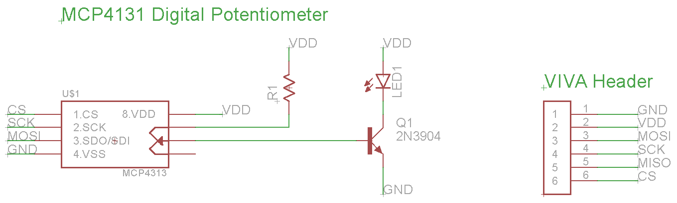

# Layout

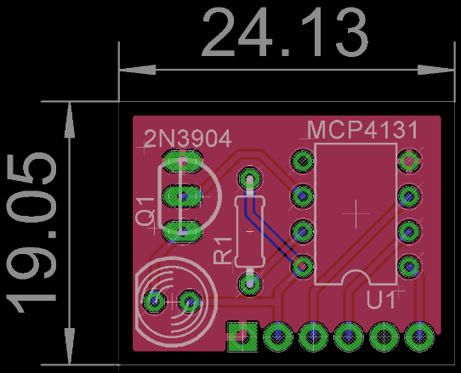

Dimensions in mm